

**M.G.N EMPEROR BANK PLC**

**Property Site Visit Photo**

1. **Property Information:**

|  |  |  |  |  |  |  |  |  |  |
| --- | --- | --- | --- | --- | --- | --- | --- | --- | --- |
| **Property Information** | | | | | | | | | |
| Property Type | : Vacant land to be constructed as 3.5-storey building with roof | | | Land area | | | | : 182 sqm | |
| Property Address | : Phum Russey, Sangkat Steung Meanchey 3, Khan Meanchey, PP | | | Estimated Building area  After 100% completion | | | | : 576 sqm | |
| Formal VR | : N/A | | | Date | | | | : 12-Jun-19 | |
| **Security Value** | **Valuation Report** | | | **Indicative Value** | | | | | |
| Land Value | : N/A | | | : USD109,200 (USD600/sqm) | | | | | |
| Building Value | : N/A | | | : USD126,720 (USD220/sqm) | | | | | |
| **OMV** | **: N/A** | | | **: USD235,920** | | | | | |
| Valuer(s) | : N/A | | | : CPL | | | | | |
| **Security Value** | **: N/A** | | | **FSV** | | | **: N/A** | | |
| **Existing Insurance** | [ ] Yes | [ ✓ ] No | **Insurer** | **: N/A** | | | | | |
| **Encumbrance** | [ ] Yes | [ ✓ ] No | **Bank Name** | **: N/A** | | | **Limit: N/A** | | |
| **Property Conditions and Adverse Impacts on Market Value** | | | | | | | | | |
| Occupancy rate of neighboring property | | | | | [ ] Poor | [ ] Fair | | | [ ✓] Good |
| Demand for sale/rent | | | | | [ ] Poor | [ ] Fair | | | [ ✓] Good |
| Incidence of crime on vicinity | | | | | [ ✓] Low | [ ] Average | | | [ ] High |
| Road accessibility to the property over 6m | | | | | [ ✓] Yes | [ ] No | | |  |
| Is the property located in flood area | | | | | [ ] Yes | [ ✓] No | | |  |
| Is the property located near loathsome facilities (ref: page 18 of CPG) | | | | | [ ] Yes | [ ✓] No | | |  |
| The property is found to be in good state of repair | | | | | [ ✓] Yes | [ ] No | | |  |
| *If No, please comment:* | | | | |  |  | | |  |
| **Brief on the property and surrounding area** | | | | | | | | | |
| * Subject property is under construction to be built as a single 3-storey building with roof. It will be occupied as room rental business and consist of 60 rooms. * It is located in Phum Russey, Sangkat Steung Meanchey 3, Khan Meanchey, Phnom Penh City, where is distanced as follow: * Within 1Km from Vattanac and Canadia Industrial Park. * Within 3km from Steung Meanchey and Trapaing Thleung Market. * Location is considered as grade A of residential type with max. LTV up 70% for land and building value as the property is currently under construction of 3-storey building with roof for room rental business. Moreover, the requested loan will be gradually released subject to completion of construction’s progress. * The property is surrounded by industrial park and housing development project such as Vattanac and Canadia, Borey Mengly, Borey Bou Aao, Borey New World, etc. as well as Factories, Schools, and many business’s activities. | | | | | | | | | |

1. **Land Shape:**

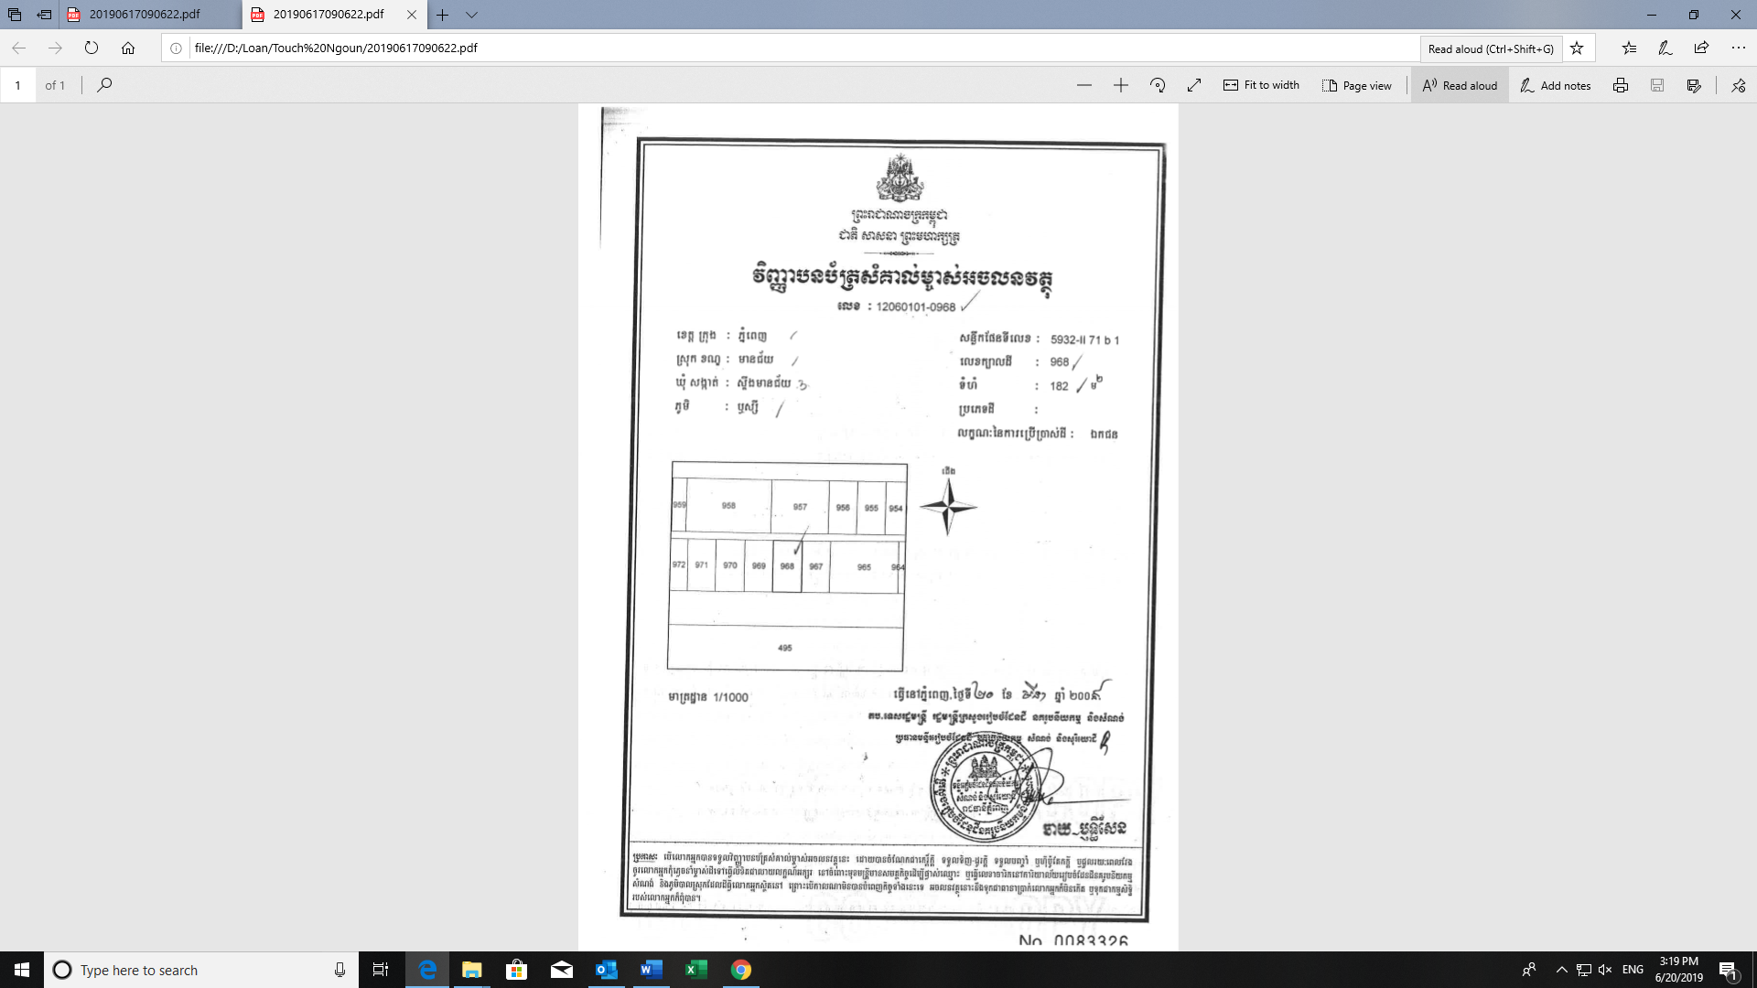

1. **Location:**

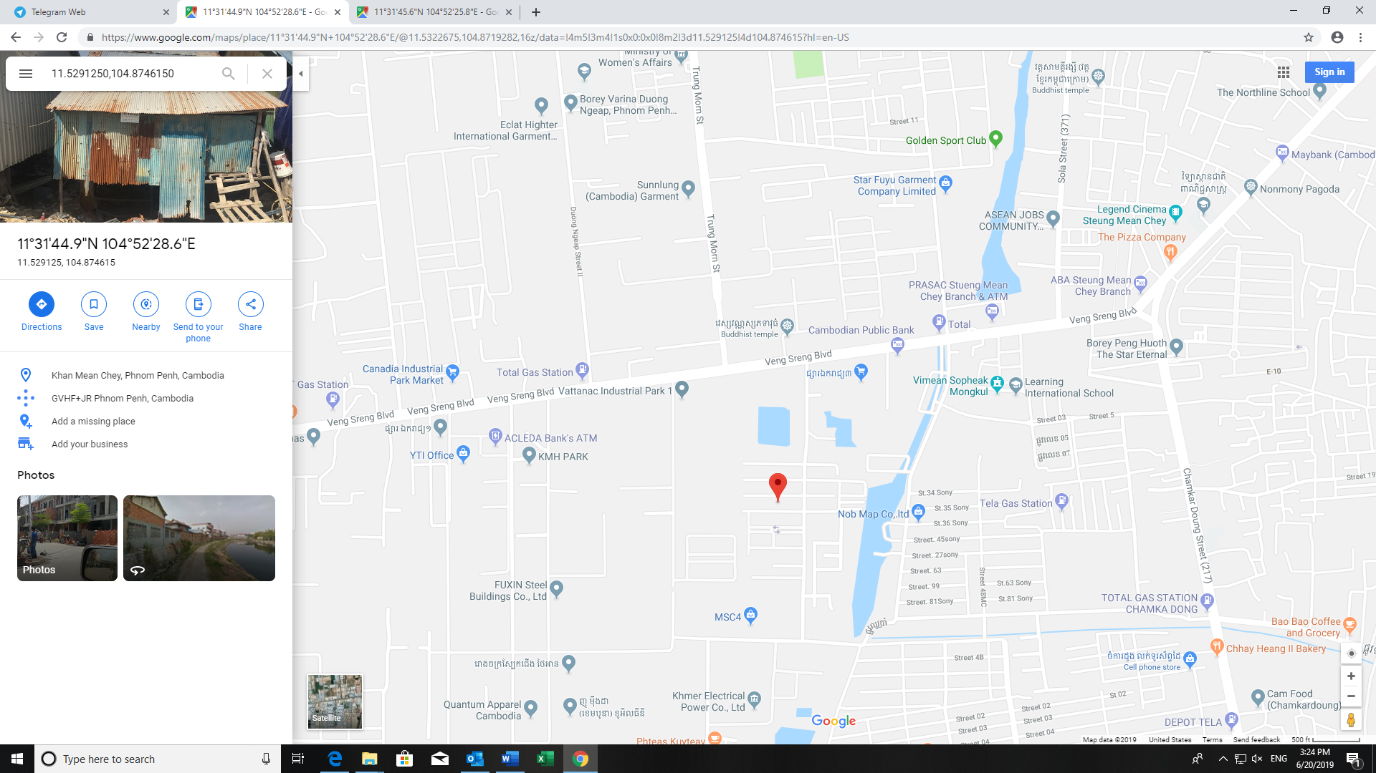

Canadia Industrial Park

Veng Sreng Street

Ek Reach 3 Market

Vattanac Industrial Park

Subject Property

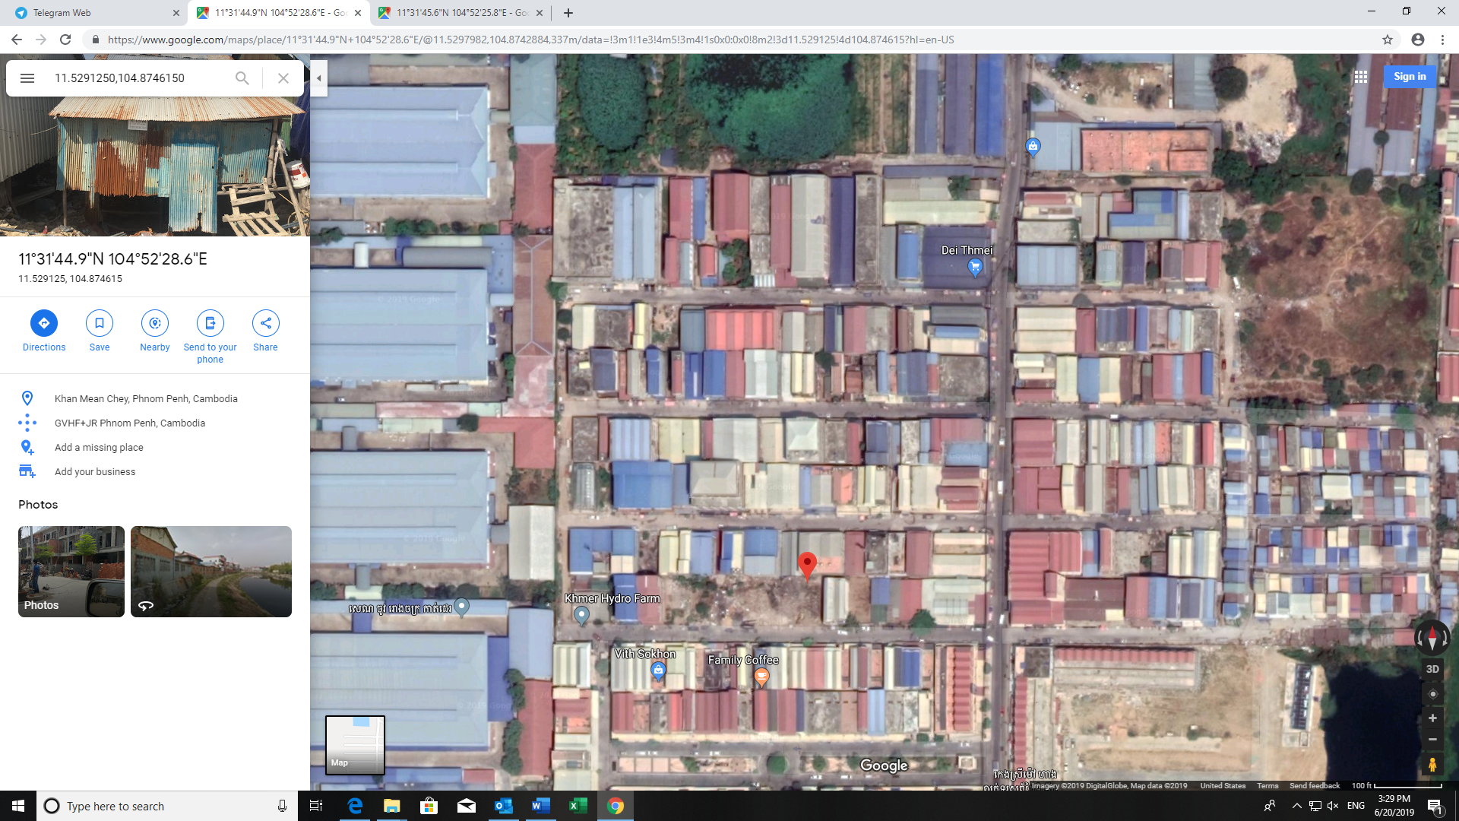

Vattanak Industrial Park

Subject Property

Borey Bou Aao

Borey Meng Ly

1. **Property Photo: (Collateral) To be constructed as 3-Storey Building with roof for room rental business**

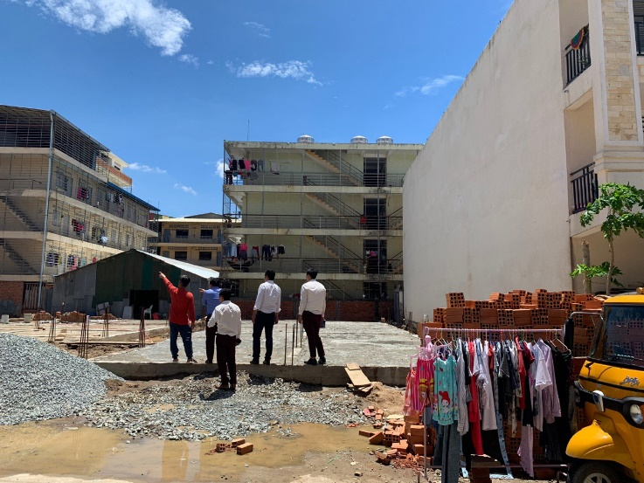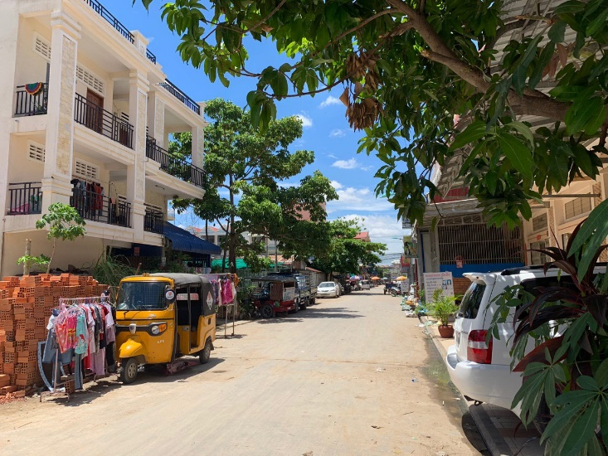

Subject Property

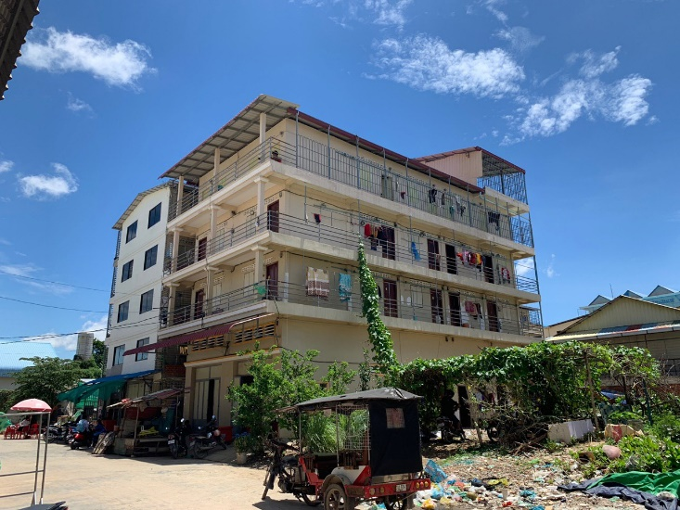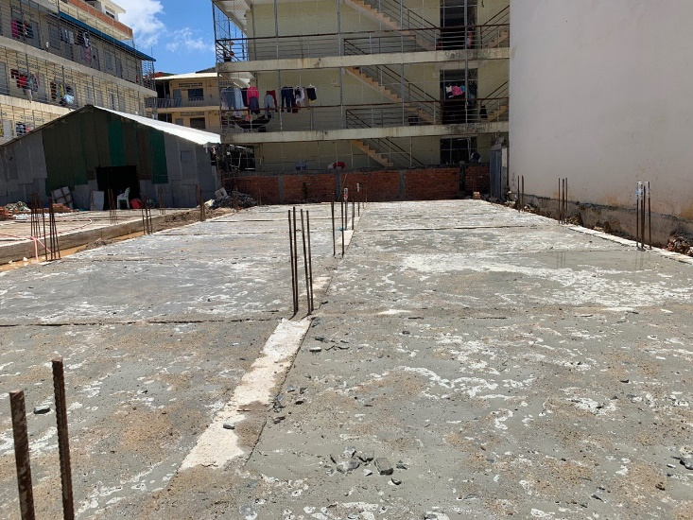

Sample Building to be constructed

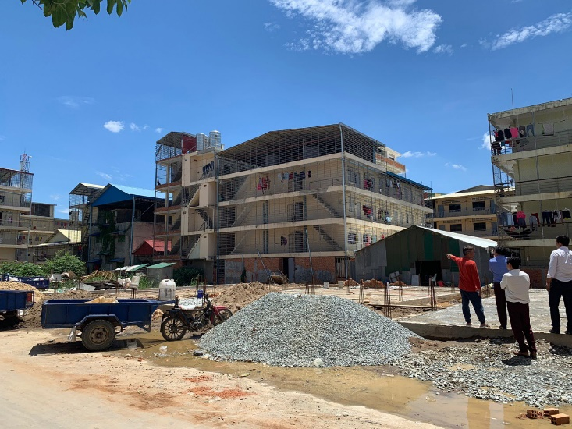

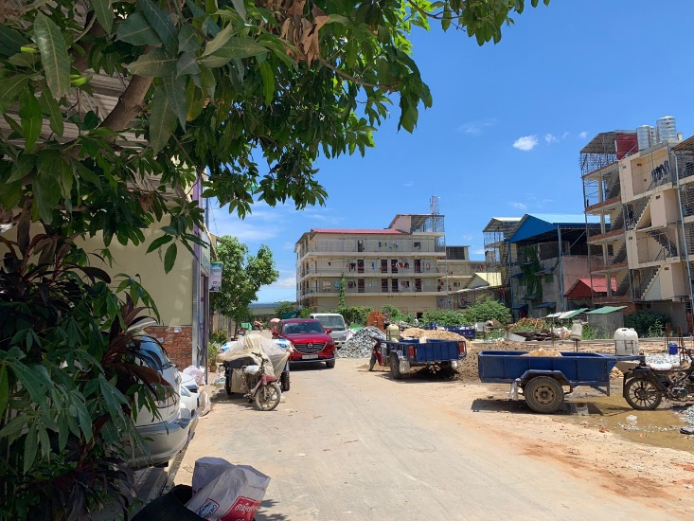

**Surrounding area**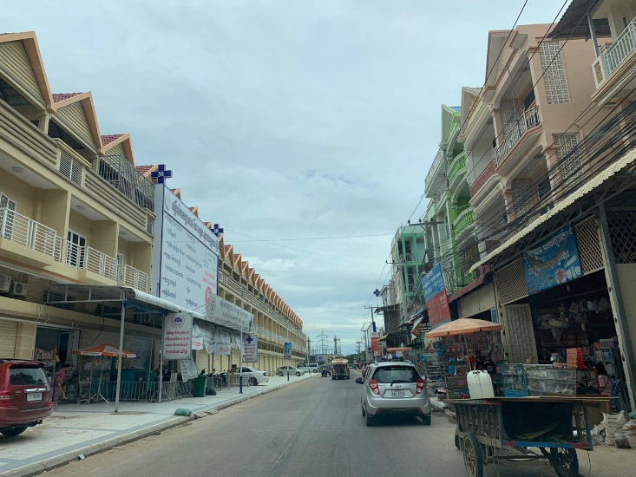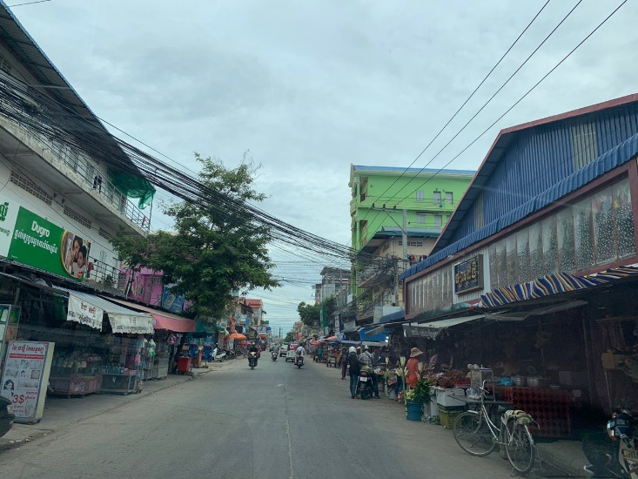

|  |  |
| --- | --- |
| Prepared by | Reviewed by |
| Mr. Sok Ratanak  Manager, Credit Analyst  Date: | Mr. Chiv Hak  Head, Business Development  Date: |

